**Union all 중복 제거 방지**

1. **Select * from sample71_a union**

**select * from sample71_b;**

1. **Select * from sample71_a union all**

**select * from sample71_b;**

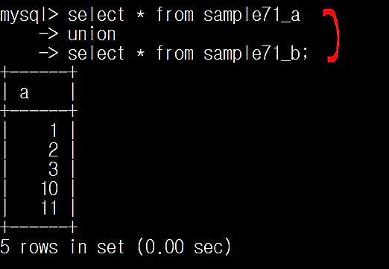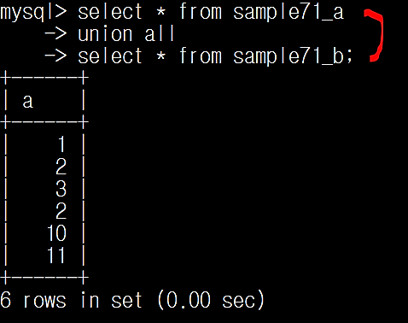

**중복된 내용을 제거하고 싶지 않은 경우 union all을 사용한다**